Grappling Manual

In order to grapple you must put the input system as old and new with DanisTutorials movement script that gives the movement toward the grappling hook.

You will also need a layer as “Ground” and “Grapple” this is to tell what object is ground and what object you can grapple on. The input system will be WASD, Space, Control, and Left click.

* WASD - Movement
* Space - Jump
* Control - Slide
* Left Click - Grapple

When making the grapple you must have this in order:

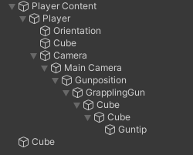

The reason for this is because you must have the camera with the grapple gun and the camera must be able to do First person movement. This is for the line render to shoot the grapple around the places the player looks at.

In order to grapple you must make sure that you hold down the left click to grapple and you are able to move in mid air due to the low gravity.

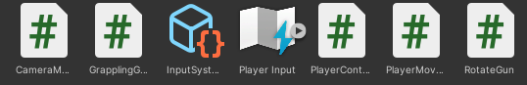

Here the code you must used and input system you must have for the grapple to work for your character.